**Final Project**

**Name:** Urazbekova Amina  
**Group:** MT-2406

**Home Page**

The home page is the welcoming section of the website that introduces visitors to Caffena Coffee. It has a navigation bar, banner, introduction text, links to other pages and a footer. The design is simple and readable with a big image in the middle. Although this page does not include JavaScript or jQuery, it shows the foundation for the site’s layout and structure, including Bootstrap for responsiveness and styling.

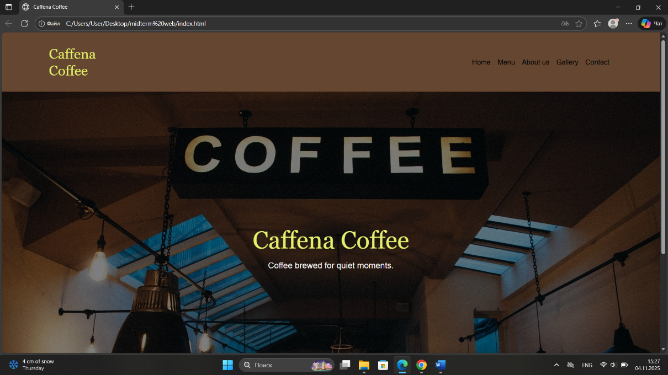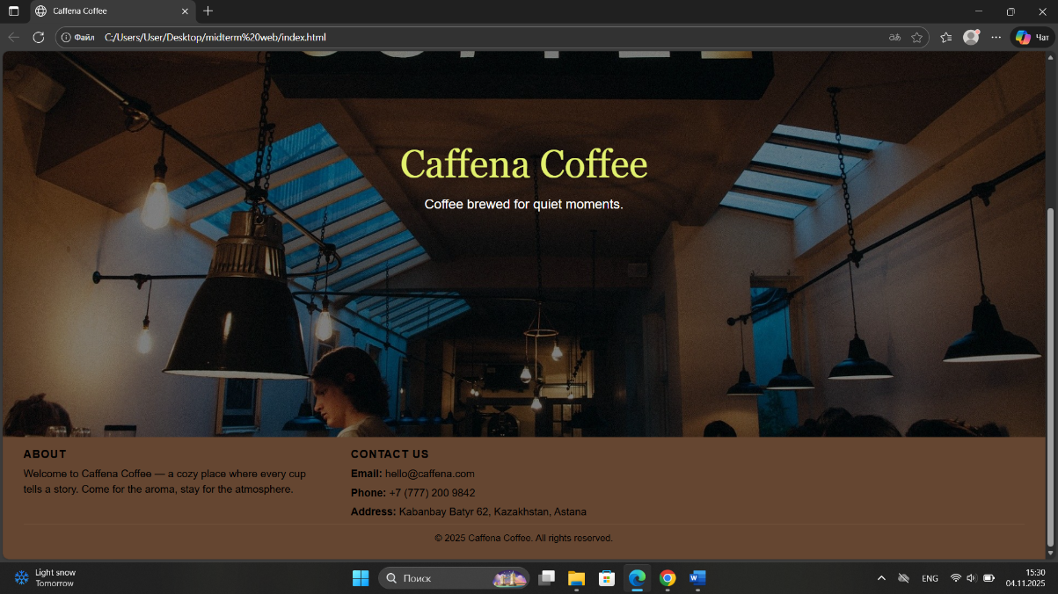

**Menu Page**

I improved the menu page with dynamic features using jQuery. The first thing that I added is the dynamic search, which allows users to quickly find drinks by typing keywords into the search bar. This search filters the items in real time without reloading the page and provides a smoother user experience. The second functionality is the modal (popup) interaction, which appears when a user chooses to order a drink. The modal has the selected drink that is automatically filled in and a short form for entering name and phone number. I also used Bootstrap’s modal component, that, makes the modal only appear when needed and does not block clicks on the page.

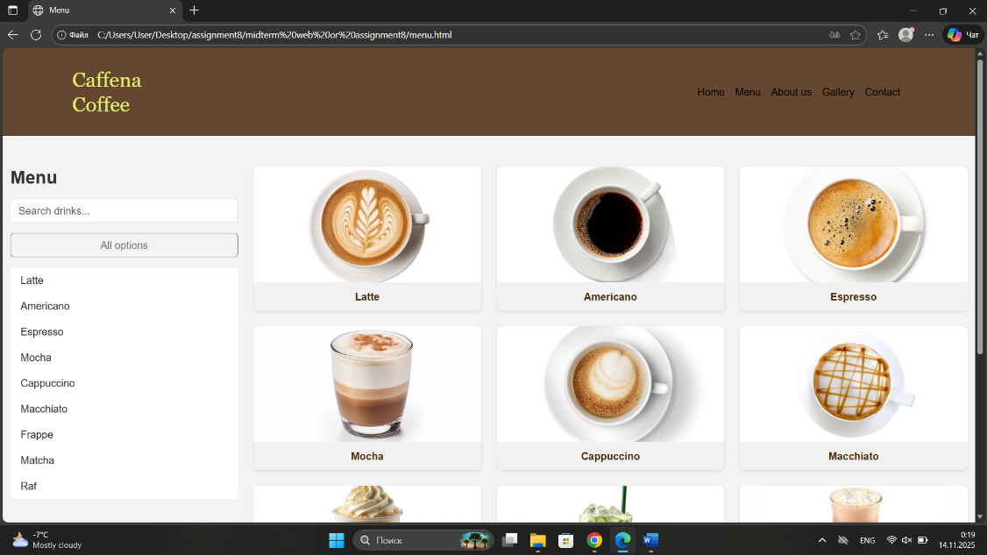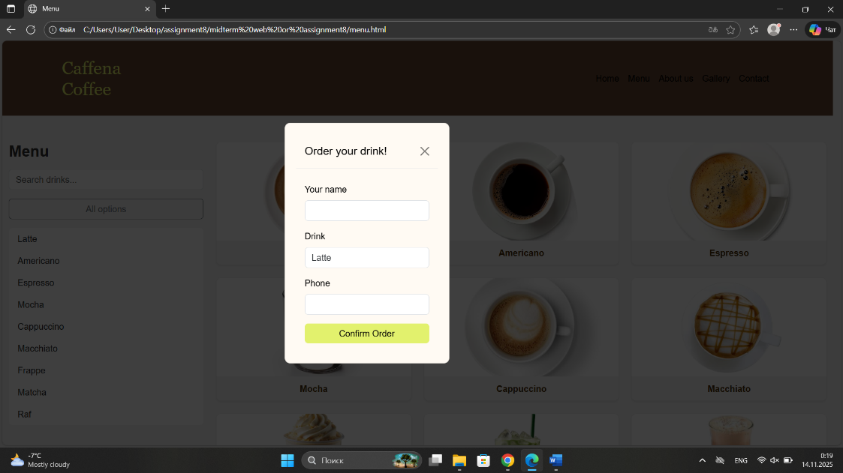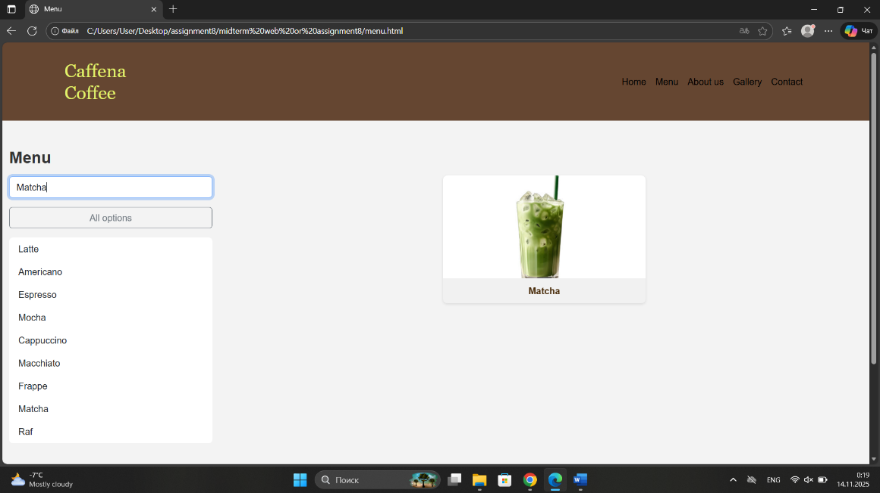

**About Us Page**

In the about page, I added an interactive dynamic table with CRUD (Create, Read, Update, Delete) operations for managing staff information. By using jQuery, I can add new staff members, edit existing ones, and remove them directly in the table. This functionality gives me opportunity to manipulate data without reloading the page, and that shows how DOM manipulation can be used for these tasks. I also have a jQuery animation here, which is a “welcome popup” that fades in when the page loads, and fades out when I press “close”. I believe this feature adds personality and makes the site more dynamic.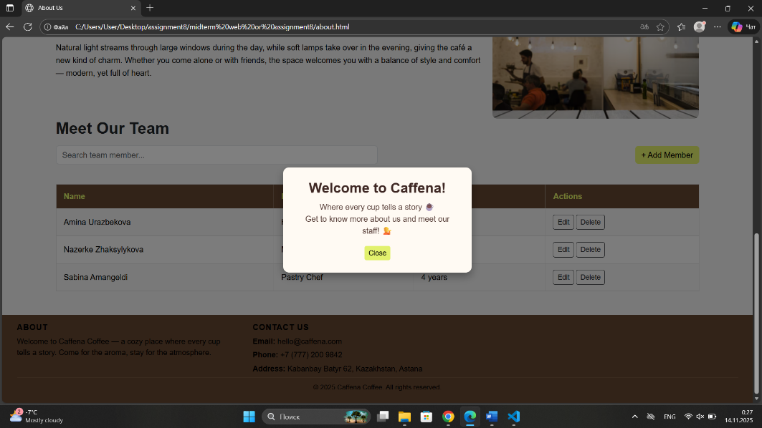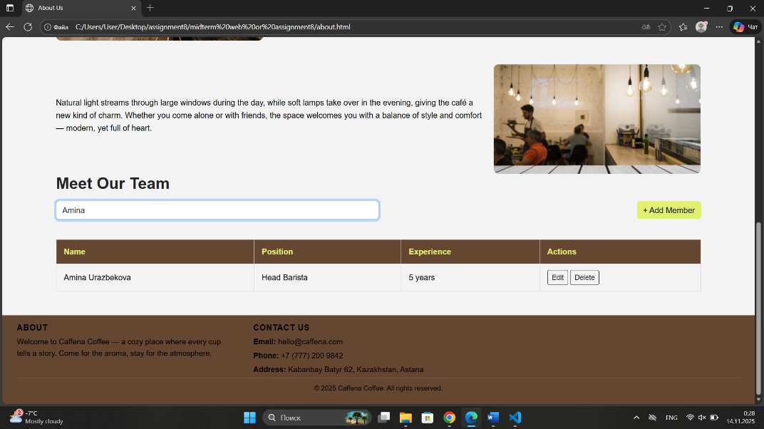

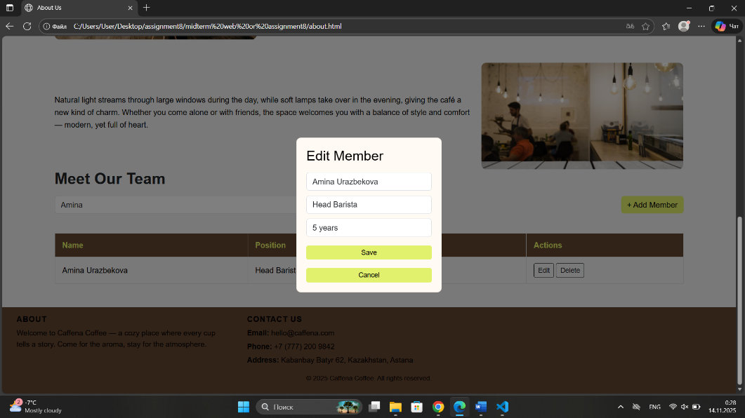

**Gallery Page**

The gallery page has a filtering and lightbox system. I added filtering to allow users to switch between categories such as drinks, desserts, and interior, dynamically showing only the selected images through jQuery event handling. Also, I used a lightbox effect for when a user clicks on an image, it would popup with a darkened background. I made it using Bootstrap classes and jQuery. So, together, these features create an engaging and visually dynamic page.

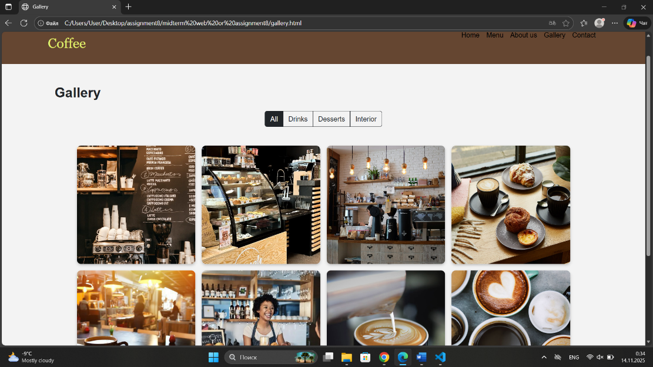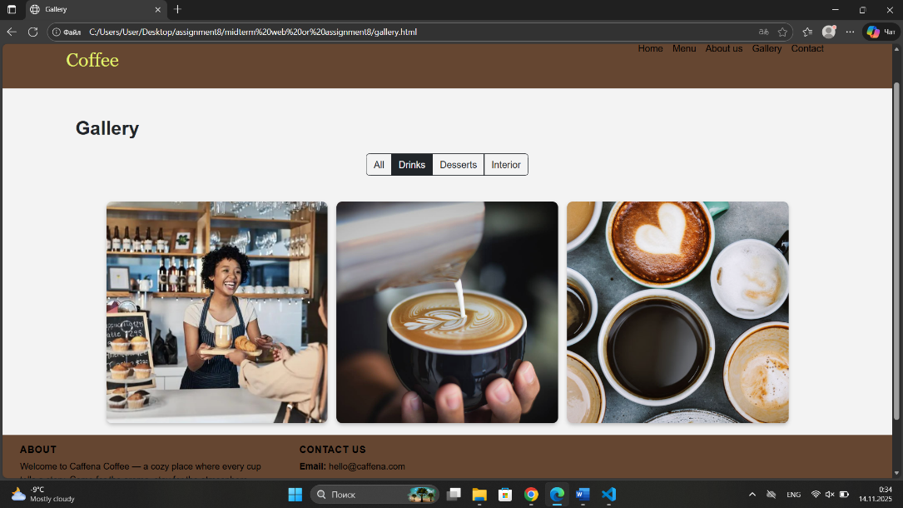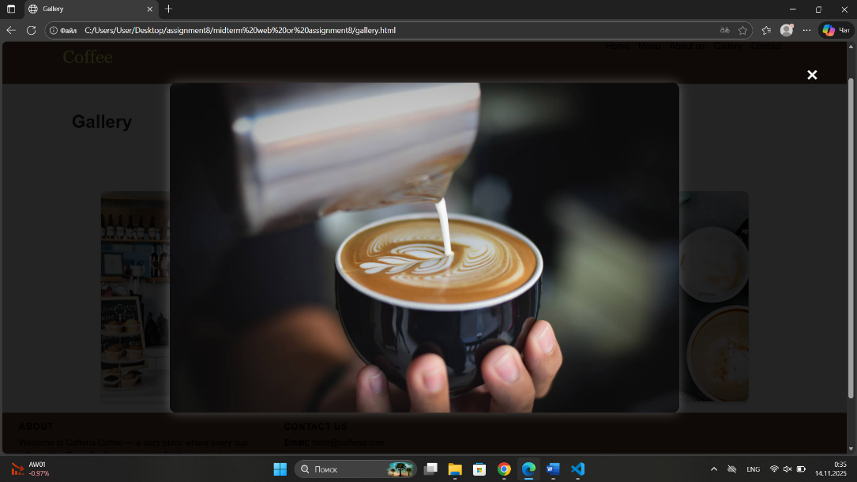

**Contact Page**

Finally, in the contact page I added a detailed form validation system using JavaScript and Regular Expressions (RegEx). The script validates user’s name, email, password, and message fields in real time. It shows visual feedback through different colors of Bootstrap alert messages. It checks the email format using RegEx, and password strength displaying real-time feedbacks as weak, medium, or strong based on length and content. The form also has password confirmation logic to be sure both fields match before submission. All validation happens before user submits the form, and that prevents the sending of invalid data.

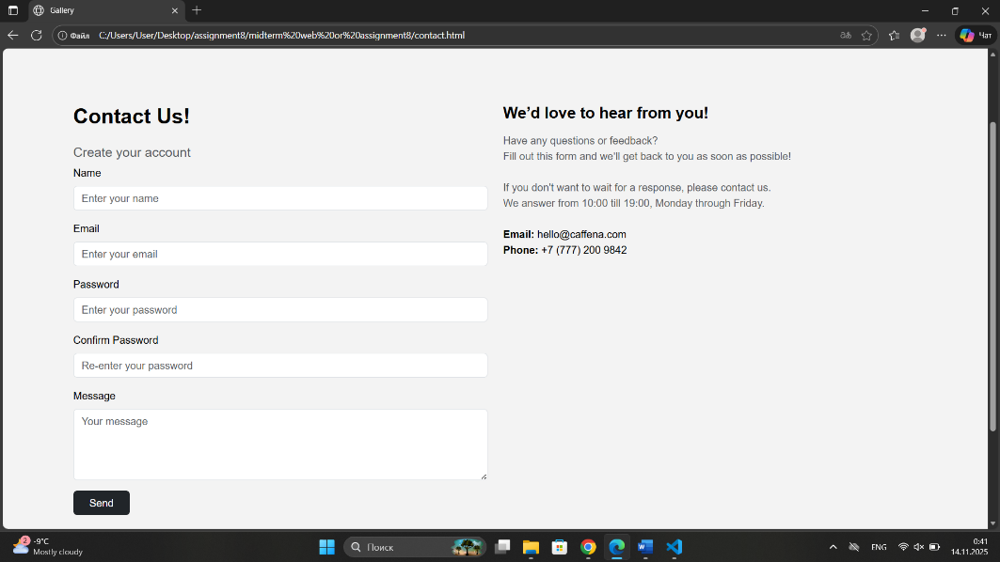

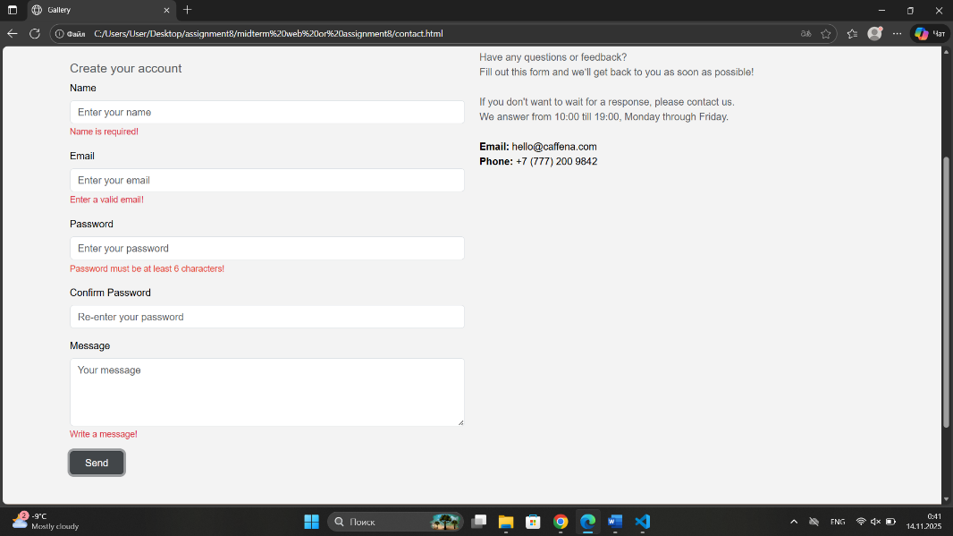

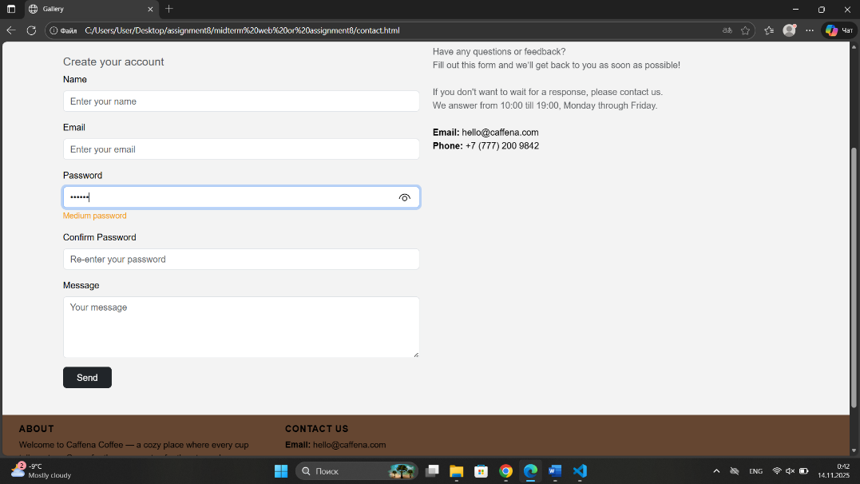

**Summary**

Throughout the development of this website, I used everything from the requirements like, HTML, CSS, Bootstrap, JavaScript, and jQuery to create a responsive and interactive coffee shop website. Each page demonstrates a different side of dynamic website structuring, from user interface improvement to data manipulation and validation. During the whole process, I learned how to integrate Bootstrap components with custom scripts, use JavaScript for form validation, and improve user experience through modals, search bars, filtering systems, and CRUD operations. This project really helped me to improve my understanding of front-end development and give me an opportunity for a practical experience in creating a complete interactive website.